​
​
UNITED STATES
SECURITIES AND EXCHANGE COMMISSION
Washington, D.C. 20549
SCHEDULE 14A
Proxy Statement Pursuant to Section 14(a) of
the Securities Exchange Act of 1934 (Amendment No. )
Filed by the Registrant ⌧
Filed by a Party other than the Registrant ☐
Check the appropriate box:
☐ | Preliminary Proxy Statement
☐ | Confidential, for Use of the Commission Only (as permitted by Rule 14a-6(e)(2))
☐ | Definitive Proxy Statement
⌧ | Definitive Additional Materials
☐ | Soliciting Material under §240.14a-12
Willdan Group, Inc.
(Name of Registrant as Specified In Its Charter)
(Name of Person(s) Filing Proxy Statement, if other than the Registrant)
Payment of Filing Fee (Check all boxes that apply):
⌧ | No fee required.
☐ | Fee paid previously with preliminary materials.
☐ | Fee computed on table in exhibit required by Item 25(b) per Exchange Act Rules 14a-6(i)(1) and 0-11.
​  ​  ​  ​  ​  ​  ​  ​  ​  ​  ​  ​  ​  ​  ​  ​  ​  ​  ​  ​  ​  ​  ​ | ​
​

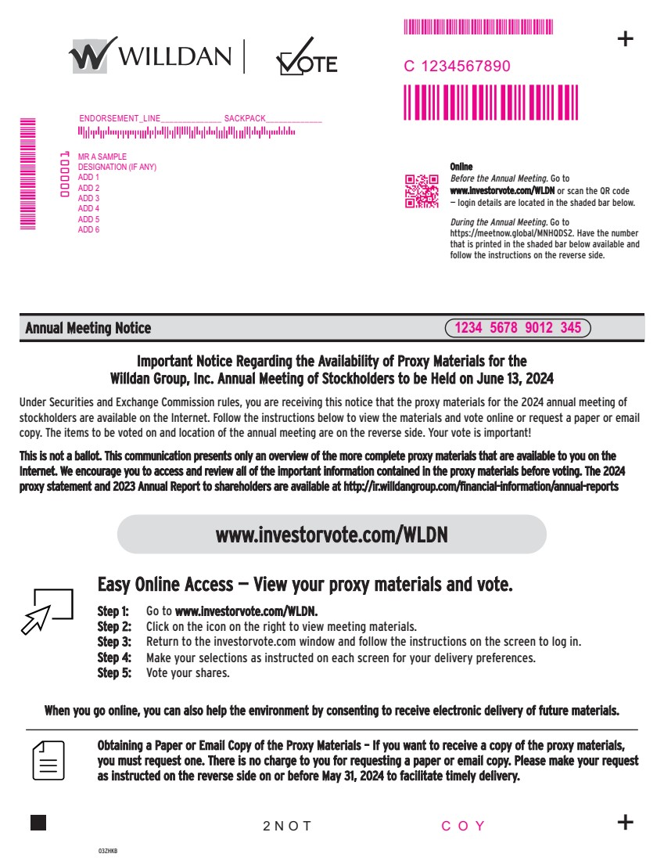 | www.investorvote.com/WLDN Step 1: Go to www.investorvote.com/WLDN. Step 2: Click on the icon on the right to view meeting materials. Step 3: Return to the investorvote.com window and follow the instructions on the screen to log in. Online Before the Annual Meeting. Go to www.investorvote.com/WLDN or scan the QR code — login details are located in the shaded bar below. During the Annual Meeting. Go to https://meetnow.global/MNHQDS2. Have the number that is printed in the shaded bar below available and follow the instructions on the reverse side. Annual Meeting Notice 03ZHKB + + Important Notice Regarding the Availability of Proxy Materials for the Willdan Group, Inc. Annual Meeting of Stockholders to be Held on June 13, 2024 Under Securities and Exchange Commission rules, you are receiving this notice that the proxy materials for the 2024 annual meeting of stockholders are available on the Internet. Follow the instructions below to view the materials and vote online or request a paper or email copy. The items to be voted on and location of the annual meeting are on the reverse side. Your vote is important! This is not a ballot. This communication presents only an overview of the more complete proxy materials that are available to you on the Internet. We encourage you to access and review all of the important information contained in the proxy materials before voting. The 2024 proxy statement and 2023 Annual Report to shareholders are available at http://ir.willdangroup.com/financial-information/annual-reports Obtaining a Paper or Email Copy of the Proxy Materials – If you want to receive a copy of the proxy materials, you must request one. There is no charge to you for requesting a paper or email copy. Please make your request as instructed on the reverse side on or before May 31, 2024 to facilitate timely delivery. 2NOT Easy Online Access — View your proxy materials and vote. When you go online, you can also help the environment by consenting to receive electronic delivery of future materials. Step 4: Make your selections as instructed on each screen for your delivery preferences. Step 5: Vote your shares. MMMMMMMMMMMM MMMMMMMMM MR A SAMPLE DESIGNATION (IF ANY) ADD 1 ADD 2 ADD 3 ADD 4 ADD 5 ADD 6 ENDORSEMENT_LINE______________ SACKPACK_____________ 1234 5678 9012 345 C 1234567890 COY MMMMMMM 000001
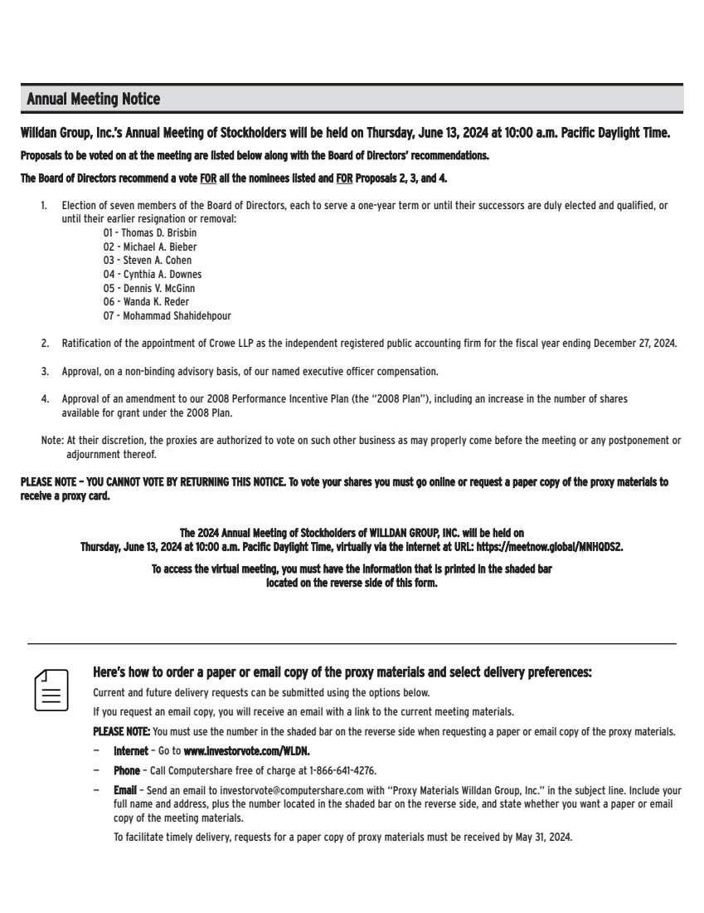 | Here’s how to order a paper or email copy of the proxy materials and select delivery preferences: Current and future delivery requests can be submitted using the options below. If you request an email copy, you will receive an email with a link to the current meeting materials. PLEASE NOTE: You must use the number in the shaded bar on the reverse side when requesting a paper or email copy of the proxy materials. — Internet – Go to www.investorvote.com/WLDN. — Phone – Call Computershare free of charge at 1-866-641-4276. — Email – Send an email to investorvote@computershare.com with “Proxy Materials Willdan Group, Inc.” in the subject line. Include your full name and address, plus the number located in the shaded bar on the reverse side, and state whether you want a paper or email copy of the meeting materials. To facilitate timely delivery, requests for a paper copy of proxy materials must be received by May 31, 2024. Willdan Group, Inc.’s Annual Meeting of Stockholders will be held on Thursday, June 13, 2024 at 10:00 a.m. Pacific Daylight Time. Proposals to be voted on at the meeting are listed below along with the Board of Directors’ recommendations. The Board of Directors recommend a vote FOR all the nominees listed and FOR Proposals 2, 3, and 4. 1. Election of seven members of the Board of Directors, each to serve a one-year term or until their successors are duly elected and qualified, or until their earlier resignation or removal: 01 - Thomas D. Brisbin 02 - Michael A. Bieber 03 - Steven A. Cohen 04 - Cynthia A. Downes 05 - Dennis V. McGinn 06 - Wanda K. Reder 07 - Mohammad Shahidehpour 2. Ratification of the appointment of Crowe LLP as the independent registered public accounting firm for the fiscal year ending December 27, 2024. 3. Approval, on a non-binding advisory basis, of our named executive officer compensation. 4. Approval of an amendment to our 2008 Performance Incentive Plan (the “2008 Plan”), including an increase in the number of shares available for grant under the 2008 Plan. Note: At their discretion, the proxies are authorized to vote on such other business as may properly come before the meeting or any postponement or adjournment thereof. PLEASE NOTE – YOU CANNOT VOTE BY RETURNING THIS NOTICE. To vote your shares you must go online or request a paper copy of the proxy materials to receive a proxy card. Annual Meeting Notice The 2024 Annual Meeting of Stockholders of WILLDAN GROUP, INC. will be held on Thursday, June 13, 2024 at 10:00 a.m. Pacific Daylight Time, virtually via the internet at URL: https://meetnow.global/MNHQDS2. To access the virtual meeting, you must have the information that is printed in the shaded bar located on the reverse side of this form.

